First Communion Dates


Saturday 22nd August 2020 in St Malachy’s Church at 1pm

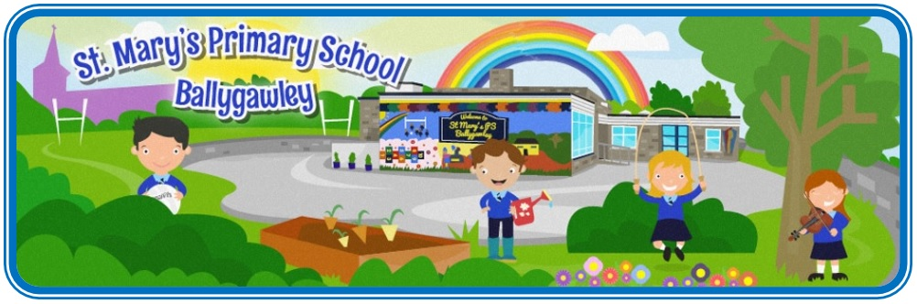

Saturday 29th August 2020
in the Church of the Immaculate Conception at 11am

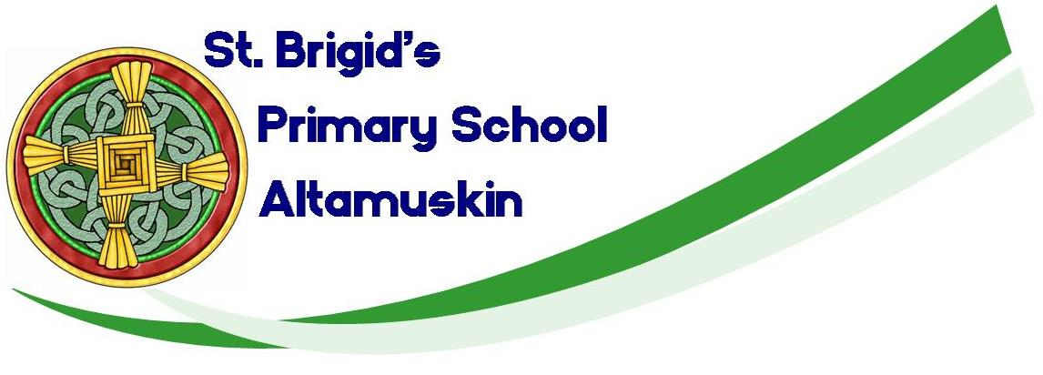

Saturday 29th August 2020 in St Mary’s Church at 1.30pm

PARISH OF ERRIGAL CIARAN
THE SACRAMENT
OF PENANCE

In the Church of the Immaculate Conception

Tuesday 11th August 2020 7.00pm

In the name of the Father, and of the Son, and of the Holy Spirit. Amen.

Welcome
Reception of the children

Celebrant

It was because of your commitment to God and the Christian Community that you brought your child to the Church to be Baptised. On that day the Christian Community gathered around to rejoice with you as your child became a member of God's family. Since then, through your love and care and with the support of those around you, your child has experienced the spirit of life and connectedness that exists in your family and in the Parish Christian community. Today in the presence once again of your friends and family, you accompany your child on a further step of his/her faith journey within the Christian community.

What do you ask of God's Church for your children?

Parents respond: -

The celebration of God's forgiveness in the Sacrament of Penance.

Even if we sometimes forget God, God never forgets us. Even when we don't love others, God still loves us.

LITURGY OF THE WORD

The Gospel.

HOMILY

EXAMINATION OF CONSCIENCE

Prayer for Forgiveness.
O my God, help me to remember the times when I didn't live as Jesus asked me to. Help me to be sorry and to try again. Amen.

LITURGY OF RECONCILIATION

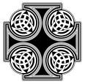
The Confiteor

I confess to almighty God and to you, my brothers and sisters, that I have greatly sinned, in my thoughts and in my words, in what I have done and in what I have failed to do, through my fault, through my fault, through my most grievous fault; therefore I ask Blessed Mary ever-Virgin, all the angels and saints, and you, my brothers and sisters, to pray for me to the Lord our God.

Our Father

INDIVIDUAL CONFESSION AND ABSOLUTION

Each parent brings their child to the sanctuary and the children then go to the priest to make their Confession.

Child: Bless me, Father, for I have sinned. This is my First Confession. I did not show love when I ….

Act of sorrow
O my God, I thank you for loving me. I am sorry for all my sins, for not loving others and not loving you. Help me to live like Jesus and not sin again. Amen.

Celebrant
God our Father loves you and God our Father forgives you all your sins and I absolve you, in the name of the Father, and of the Son, and of the Holy Spirit. Amen.

PRAYER AFTER FORGIVENESS
O my God, thank you for forgiving me. Help me to love others. Help me to live as Jesus asked me to. Amen.

